Chapter 8, Solution 21.

By combining some resistors, the circuit is equivalent to that shown below. 60||(15 + 25) = 24 ohms.
6 Ω
24 Ω
i
t = 0
+
v
−
3 H
(1/27)F
24V

+
−
12 Ω

At t = 0-, i(0) = 0, v(0) = 24x24/36 = 16V

For t > 0, we have a series RLC circuit. R = 30 ohms, L = 3 H, C = (1/27) F

- = R/(2L) = 30/6 = 5

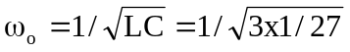 = 3, clearly α > ω_{o} (overdamped response)

s_{1,2} = 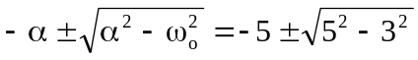 = -9, -1

v(t) = [Ae^{-t} + Be^{-9t}], v(0) = 16 = A + B (1)

i = Cdv/dt = C[-Ae^{-t} - 9Be^{-9t}]

i(0) = 0 = C[-A – 9B] or A = -9B (2)

From (1) and (2), B = -2 and A = 18.

Hence, v(t) = (18e^{-t} – 2e^{-9t}) V

